Job title: | Senior Maintenance Operative
Responsible to: | Director of Facilities
Holiday/Sickness Relief: | Maintenance Operatives
Salary: | £30,000 per annum
Hours: | 37 per week, Monday to Friday

Purpose of the Job

To promote and work within our values:
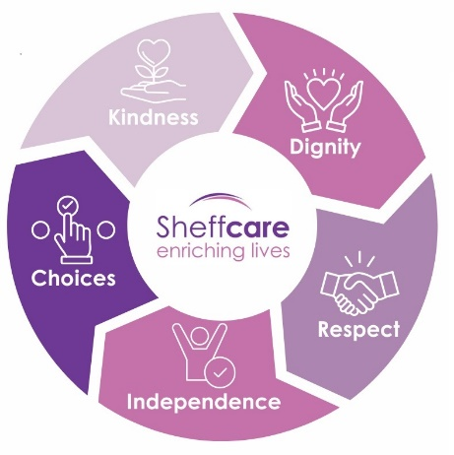
To help ensure that our buildings, equipment and fixtures are maintained in good, safe working order, compliant with health safety regulations and the Care Act and our records are up to date.

To be the maintenance operative at one of our nine care homes.

To work within our Leadership Charter

Specific Duties & Responsibilities

- To be aware of and work within Company policies and procedures (as determined by Sheffcare Board/Chief Executive) ensuring that all applicable legislation is implemented.

- Coordinate/Manage general repairs and maintenance at all Sheffcare sites, currently 9 care homes, a small central support service office and two day care services

- Carry out 1:1s for the maintenance team, currently three people

- Coordinate/manage proactive/reactive compliance procedures for Legionella, Fire and H&S, including PAT, Nurse Call and M&E by prioritisation and allocation of resources

- Be the lead maintenance operator at one Sheffcare home

- To conduct routine checks on vehicles tyres, water and oil etc. reporting any faults to the Director of Facilities. To maintain minimum fuel levels filling vehicle as necessary. Maintain vehicle log sheets.

- To operate the appropriate stock control systems.

- To carry out fault finding on mechanical and electrical systems.

- Provide direct maintenance support when operatives are on leave / sick

- Act as the point of contact for the Director of Facilities in his absence

- Attend Health and Safety Employee Forums

- Prepare all maintenance Purchase Orders (PO) for the Director of Facilities to authorise

- To be aware of and work within Charity policies and procedures (as determined by Sheffcare Board/Chief Executive) ensuring that all applicable legislation is implemented.

- To carry out all duties with due regard to Health & Safety legislation and to the Health & Safety Policy of Sheffcare Ltd

- To carry out specific delegated duties as directed by the Director of Facilities

- To respect the privacy and dignity of our residents and clients, ensuring confidentiality at all times.

- To understand and comply with fire precaution procedures and health and safety regulations.

- To participate in all meetings, reviews, staff development/training and supervision within Charity policies.

- To drive light vans transporting materials in a safe and efficient way. Ensure all materials are loaded safely and securely.

- To undertake any other duties applicable to the grade and post.

- Any other reasonable request made by a member of the management team.

- To undertake programmes of Planned Preventative Maintenance with respect to buildings, plant, machinery, equipment, furniture and fittings.

- To undertake all emergency and reactive maintenance and repair of buildings and landscape, plant, machinery, equipment, furniture and fittings, including tiling, painting, plumbing, joinery etc, as required.

- To install new and remove old machinery, equipment, plant, furniture and fittings.

- To carry out all duties with due regard to Health & Safety legislation and to the Health & Safety Policy of Sheffcare Ltd

- To carry out specific delegated duties as directed by the Director of Facilities

- To operate and provide information for the computerised works order system.

- To operate the appropriate stock control systems.

- To maintain detailed knowledge and understanding of all mechanical and electrical systems contained within the facilities.

- To carry out fault finding on mechanical and electrical systems.

Person Specification

Essential

- Full Clean Driving Licence
- Experience of supervising a small team maintenance team
- Understanding of Health & Safety compliance.
- Able to undertake manual work.
- Positive disposition.
- Proactive approach to work.
- Solid experience in maintenance and repair, buildings and facilities, DIY, cleaning and housekeeping.
- Technical knowledge of mechanical and electrical systems
- IT skills.
- Literacy skills sufficient to write succinct and professional management papers and reports
- Numeracy skills sufficient to be able to work within budgets.
- Communication skills sufficient to present to senior management and to provide advice and instruction to colleagues and external contacts at all levels.
- Ability to plan work, prioritise tasks, organise staff and resources.
- Self-motivated and can work on own initiative
- Ability to work as a member of a team.
- Ability to work methodically under pressure.
- Ability to work in a flexible and responsible way.
- Ability to train others and lead by example
- A willingness and ability to undertake training required for the role

Desirable

- IOSHH (or equivalent) Health and Safety
- Institute of Workplace and Facilities Management level 3 or above
- Recognised trade qualification
- Similar role within residential care home or relevant non-profit organisation.
- Risk assessment completion.
- Construction, electrical and plumbing skills.
- Experience of working around older people / people living with dementia.
- An understanding of Resident safeguarding

This job description indicates only the main duties and responsibilities of the post. It is not intended as an exhaustive list.

I confirm I have received a copy of this job description

Name:

Signature:

Date:

